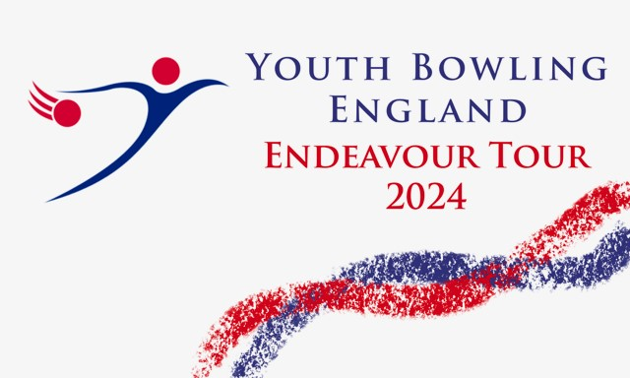
The South West
Youth Doubles 2024
Sunday
7th April 2024

Stroud Bowl
19/20 Merrywalks
Stroud
GL5 1QA

BTBA Sanction Number:- 24/00344

Both freefall and string averages will be accepted without differentiation
Before, during and after the event there could be photography, filming or video taken of participants and medal winners by anyone attending the event, either as an official, spectator, parent or guardian. If you (as a participant, parent or guardian) object to this, you must make your objections known to the tournament manager prior to the event starting and reasonable adjustments will be made.
Entry Form 2024

Name M/F Average D.O.B. B.T.B.A. No
(In playing Order) Team Name:-
Total Team Average:- Division:-
Total Team Average:- Division:-
Total Team Average:- Division:-
Total Team Average:- Division:-

Squad Times
07/04/24 Sqd “A” 09.00 Sqd “B” 13.30

Registration 30mins prior to roll off.
Maximum 12 teams per squad.
Y.B.C.
Contact Name Address
Tel / Email

Squad Required 1st choice 2nd Choice

Rules and Conditions

This is a YBE Endeavour Tour event and will be sanctioned by the BTBA and their rules will govern this event along with the following rules and conditions. The tournament is open to BTBA members and membership will be checked on the website. Open to bowlers Under 22 as at 31st December 2024

This will be a scratch doubles event throughout with teams being split into four average groups, Div 1:- Combined Avg of 351 and above, Div 2:- 291 to 350, Div 3:- 246 to 290, Div 4:- 245 and below. Each team will bowl six games changing lanes after every two games.

Entrants must declare their highest average in any league, tournament or merit table (Junior or adult) over 18 games on the day of bowling.

The tournament manager, Brian Parker, Reserves the right to refuse or rerate any entry he considers just cause to do so. Any protests must be lodged by YBC official / Bowler within 30 mins and confirmed in writing within 72 hours. A provisional ball must be rolled if a dispute relating to pinfall cannot be resolved immediately. The tournament manager’s decision is final subject to an appeal to the B.T.B.A.

No bowler is allowed to drink alcohol anywhere in the bowling centre during the tournament. Profane language or the abuse of bowling equipment / Machinery may result in disqualification. Any bowler disqualified will be reported to the B.T.B.A.

Competitors should wear suitable bowling attire, shirts should contain either YBC or Bowlers names. Denim is not allowed, dress shorts may be worn. YBC officials / coaches should also follow the YBE dress code. Mobile phones should not be taken into the bowler’s area during play.

Only bowlers, tournament officials or one licensed instructor / coach per team are allowed in the playing area. Instructors / coaches should display their licences.

Closing date for entries will be 29/03/2024

Entry fees must be paid in full by the closing date. No entry fees will be refunded after squadding except in the case of the tournament being cancelled.

Entry fee will be £90.00 (£45.00 per bowler). To include £60.00 lineage, £20.00 prize fund and £10.00 expenses which includes sanction fee.
Entry fee payable by Bank transfer to:- Torquay Tournament A/C Sort code:- 557001. A/C No 43811132 ref SWD24 and bowlers / YBC name.
Tel 07796778321 Email brigillparker@aol.com website www.bptournaments.org.uk

Max 16 teams per squad. First come first served.

