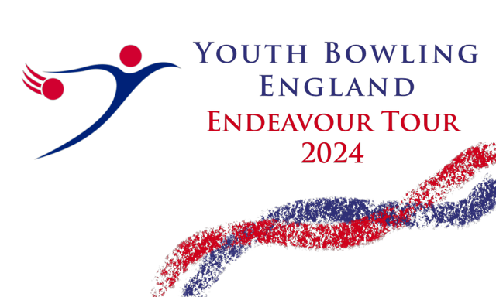

The Northern Junior Challenge
2024

Saturday / Sunday 2nd/3rd March
Ashby Bowl
170, Grange Lane S
Scunthorpe
DN16 3BJ
01724 852852
Sanction Number 24/00343
All enquiries please speak with Brian Parker on 077796778321 or brigillparker@aol.com
Both freefall and string averages will be accepted without differentiation
Before,during, and after the event there gould be photography,filming or video taken of participants and medal winners by anyone attending the event, either as an official,spectator,parent, or guardian. If you (as a participant, parent or guardian) object to this, you must make your objections known to the tournament manager prior to the event starting and reasonable adjustments will be made.
Closing Date for Entries 23/02/2024

- This BTBA sanctioned scratch singles event to be bowled at Trios pace over four games with the best 3 games being counted as the final best 3 series. A trophy prize will be awarded to 1st, 2nd and 3rd places of each category below, subject to the number of entries. The presentation will be held within 30 minutes of receipt of all final scores at the end of the day.
Division C: Bowlers with an average between 126 - 150
Division D: Bowlers with an average between 101 - 125
Division E: Bowlers with an average between 0 – 100
Entrants must declare their highest average in any league, tournament or merit over 18 games on the day of bowling. YBC officials must submit a current league standing sheet seven days prior to bowling.
This tournament is sanctioned by the BTBA and their general/tournament rules will govern the event.
Memberships will be checked on the BTBA database which is available on btba.org.uk
Registration will be 30 minutes prior to the start time and bowling will commence when all bowlers are present and ready. Latecomers will commence at the frame in progress, at the discretion of the Tournament Manager, Brian Parker.
- Squadding will take place on a “first come first served” basis (Max 30 per Squad) and lanes are allocated randomly on the day. The Tournament Manager reserves the right to reject or re-rate any bowler and his decision on all matters shall be final, subject to appeal to the BTBA.
- Protests during play must be lodged by an official and/or player within 30 minutes and confirmed in writing before the presentation. A provisional ball must be rolled if a dispute relating to pinfall cannot be resolved immediately.
- No competitor will be allowed to smoke or consume alcoholic beverages at any time during the tournament and any infringement will result in immediate disqualification. Inappropriate behaviour including profane language, improper gestures or abuse of bowling equipment or machinery may also result in disqualification and result in the loss of scores and awards. The facts will also be reported to the BTBA.
- Competitors must wear correct bowling attire in the playing area to satisfy BTBA expectations. Shirts bearing the players name and/or name of their YBC are permissible. Trousers. Skorts or leggings with no markings are permitted. No sponsorship of alcohol and tobacco products are permissible. Denim clothing, cargo style trousers/shorts will not be permitted. The wearing of headgear as a fashion item will not be permitted and will be at the discretion of the tournament manager. Personal electronic goods will not be permitted in the bowling area under any circumstances in the interests of safety and to minimize distraction to others.
- Only competitors, tournament officials and licenced coaches will be allowed in the playing area. Licenced Coaches must also follow the same dress code as bowlers, display their Coaching Licence and should be limited to no more than one coach per pair of lanes. Spectators are expected to view from behind the threshold. Please be aware before, during, and after the event there could be filming, action photography or video taken of participants and medal winners by anyone attending the event, either as an official, spectator, parent or guardian .If you (as a participant, parent or guardian) object to this, you must make your objections known to the tournament manager prior to the event starting and reasonable adjustments will be made.
- Entry fees MUST accompany a fully completed entry form (see below). Confirmation of booking will be made by email on receipt of full entry fee and booking form. Except in the case of cancellation of the tournament, no entry fees will be refundable after the closing date. Enquiries regarding available space can be made via email at brigillparker@aol.com.
- The entry fee will be £30.00 per bowler which includes £14.00 Lineage, Prize Fund and Expenses to incl £2.00 Sanction Fee. (Prize fund returned 100%)
- Entry fee to be paid online to:- Sort code 55-70-01 and Account No 74542729. A/C name North of England Open. using the reference NJC24(YBC Name) and the electronic entry form via email to brigillparker@aol.com.com. to arrive by Friday 23rd Feb 2023 or by post for the attention of: Brian Parker, 10, Oaklawn Court, Barton Road, Torquay, Devon, TQ1 4EN.

Northern Junior Challenge 2024 Entry Form
Bowlers Name (Block Capitals) | Date of Birth | Gender | Association Number | Average

Contact Name / YBC
Address:
Telephone Number
Email Address:

Squad A  (02/03/24) | Squad B (03/03/24) | Squad C  (03/03/24)
13.00 Roll Off | 09.30 Roll Off | 13.00 Roll Off
Please indicate / circle your preference for either squad A, B or C.

If you want to enter more than 12 bowlers, please print off and use another form or email me the details.

Bowlers to arrive 30 mins before bowl off
Max 30 Bowlers per squad.

